 | TECHNICAL SITE SURVEY REPORT (SWAP)
 | Site Number: | XXX -XXX | Site Name: | TEMPLATE

1 BASIC SITE INFORMATION

  - Site (Candidate) Details
Site type RT - GF - EXT: |  | Site Latitude: |  | º ’ . ” | Site Longitude: |  | º ’ . ”
Site address:

Site Provider Detail
Name: |  | Position: |  | Telephone No.:
Address:
Mobile No.: |  | Fax: |  | E-Mail:
Comments:

On-Site Contact Details
Name: |  | Position: |  | Telephone No.:
Mobile No.: |  | Fax: |  | E-Mail:
Comments:

2) (SWAP) - TECHNICAL SITE SURVEY DETAILS

2.1) Technical Site Survey Status
TSS Type | BTS Indoor | BTS Outdoor |  | BSC |  | TC | OTHER
Date of TSS: |  |  | TSS Report prepared by:
Name | Discipline |  | Company |  | Attendance Signature |  | Accept | Reject
 | RF Engineer
 | TX Engineer
 | Customer representative
 | Site Acquisition
 | Civil Work Contractor
 | Engineering & Design
 | Equipment Vendor
 | Provider/ Owner
 | Other………………..
If rejected, state reasons:
Signature of attendance with an accepted tick box indicates that document was completed according to what was established during site survey

3) RADIO FREQUENCY ENGINEERING & PLANNING

Site Type: Greenfield Rooftop Indoor Microcell Others: …………………….................
Band | 900 MHz |  |  | Other equipment in antenna system
Sector | 1 | 2 | 3 | TMA | Combiner |  | MCM
Antenna Type Number |  |  |  | DD-TMA | Duplexer |  | DIPL
Number of Antennas |  |  |  | 2-way splitter |  | 3-way splitter
Antenna Orientation | º | º | º | Other information:
Antenna Mec. Tilt (deg.) | º | º | º
Antenna Height (m)  (Bottom of ant. to ground) | Mt | Mt | Mt
Feeder type: | / | / | /
Feeder Length: | Mt | Mt | Mt
BTS / BSC / TC Type
BTS Configuration

FEEDER CABLES – GUIDELINES |  |  | ANTENNA - GUIDELINES
½ inch | 1m to 23mt |  | A
7/8 inch | 23m to 65m |  | B
1 5/8 inch | 65m to 115m |  | C

4) TRANSMISSION DATA

4.1) Microwave – TX responsible
 | MICROWAVE
 |  | MW2 | MW3 | MW4 | MW5 | MW6
Microwave height :
Azimuth / orientation:
Microwave diameter (size):

4.2) Lease Line – TX responsible
Is permanent Lease line connection required: | Yes | No | If known state location (distance) of Lease line equipment / connection point:
Comments:

4.3) BTS Features / Configuration - RF responsible
BTS Location: | Indoor Shelter | Indoor Room |  | Outdoor
BTS Configuration: | Configuration 1 – (1+1+1) TRU’s  Configuration 2 – (2+2+2) TRU’s |  | Configuration 3 – (3+3+3) TRU’s  Configuration 4 – (4+4+4) TRU’s
If Outdoor, Number of BTS Cabinets site designed for: | 1 BTS Cabinet  2 BTS Cabinets |  | 3 BTS Cabinets  BTS Cabinets to be positioned separate from each other.
Comments:

- CIVIL WORKS – MATERIALS REQUIRED – GSM MATERIALS
5.1) Site Features – Civil Works & Design
Site type: | Greenfield |  |  |  |  |  |  |  | Telecom Provider Infrastructure
Site type: | Site Share (Greenfield) |  |  |  |  |  |  |  | Power Pylon
Site type: | Rooftop |  |  |  |  |  |  |  | Indoor solution
Site type: | Rooftop (Co-location)
Site type: | Rooftop (Site Share) |  |  |  |  |  |  |  | Other (state)……………………………
Installation type / Antenna support: |  |  |  |  |  |  |  |  | Face mounts
Installation type / Antenna support: | Monopole |  |  |  |  |  |  |  | Pole mounts
Installation type / Antenna support: | Panel Tower |  |  |  |  |  |  |  | Stub mast
Installation type / Antenna support: | Existing support infrastructure |  |  |  |  |  |  |  | Central tripod |  |  |  | Ballast
Installation type / Antenna support: | Chimney |  |  |  |  |  |  |  | Tripods
Installation type / Antenna support: | Other ………………………… |  |  |  |  |  |  |  | Rooftop monopole (braced pole)
BTS location and type: | Shelter 3Mt x 3Mt |  |  |  |  |  |  |  | Same level roof as antenna & MWave
BTS location and type: | Shelter 3Mt x 6Mt |  |  |  |  |  |  |  | Lower level rooftop
BTS location and type: | Shelter 4Mt x 8Mt |  |  |  |  |  |  |  | Other …………………………
Show details on sketches attached | Existing BTS room (state available space) |  |  |  |  |  |  |  | TOWER HEIGHT (NEW / EXISTING) |  |  |  |  |  | MT
Show details on sketches attached | H: | __ | W: | __ | D: | __ |  |  | Compound size in MT |  |  |  |  |  | OTHER
Show details on sketches attached | New BTS room required (state dimensions) |  |  |  |  |  |  |  | 10x10 | 12x12 |  |  |  | 15x15
Show details on sketches attached | H: | __ | W: | __ | D: | __ |  |  | * If practical more than one box may be ticked
BTS floor location: | Basement |  |  |  |  |  |  |  | Intermediary floor (state i.e. 3rd ) |  |  |  |  |  |  | ……...
BTS floor location: | Ground level |  |  |  |  |  |  |  | Roof top level
Air Conditioning | Existing on Site Y N |  |  |  |  |  | Type: SPLIT UNIT WINDOW |  |  |  |  | Qty: …………………..
Air Conditioning | NEW suggested Y N |  |  |  |  |  | Type: SPLIT UNIT WINDOW |  |  |  |  | Qty: …………………..
Structural integrity, suitability: | No Problem foreseen |  |  |  |  |  |  |  | To Be determined
Structural integrity, suitability: | Roof bearing capacity not adequate |  |  |  |  |  |  |  | Poor condition of existing steel / masonry structure / construction
Structural integrity, suitability: | Poor condition of existing timber structure |  |  |  |  |  |  |  | Poor condition of existing roof covering (eg. Asphalt)
Structural integrity, suitability: | Significant reconstruction and support bracing required |  |  |  |  |  |  |  | Fragile structure / surfaces (i.e. Glass roofs - state)
Structural integrity, suitability: | Significant structural work required |  |  |  |  |  |  |  | Potential Greenfield foundation / groundwork’s stability issues
Comments:

5.2) Site Access – Civil Works & Engineering
Ease of access ranking: | Regular Car |  |  |  |  | 4x4 |  |  |  |  |  |  |  | By Foot
Vehicular access route : | Hard Standing |  |  |  |  | Gravel |  |  |  |  |  |  |  | To Construct
Delivery of materials to site: | Truck |  |  | 4 WD |  |  |  |  | Helicopter |  |  |  |  |  |  |  | Manual Delivery
Lifting of BTS Equipment | Hand Lifted |  |  |  |  | Hoist |  |  |  |  | Building Elevator
Lifting of BTS Equipment | Cherry picker |  |  |  |  | Crane |  |  |  |  | Other (state)
Smallest Doors to be access with BTS equipment | Width | cm |  |  | Materials |  |  | Size of BTS room Door |  |  |  | Width |  |  |  | cm |  | Materials
Smallest Doors to be access with BTS equipment | Height | cm |  |  |  |  |  |  |  |  |  | Height |  |  |  | cm
Site Security during construction: | Security Guard Present |  |  |  |  |  | Security Guard Not Required |  |  |  |  |  |  |  | Security Guard Required
Site Access Conditions during Construction: | 24 Hour -- 7 days  Holidays included |  |  |  |  |  | Monday to Friday access only |  |  |  |  |  |  |  | Other Conditions  _______________

5.3) SUMMARY OF ACTIVITY, MATERIAL SUPPLY & AVAILABLE ON SITE ITEMS
RENOVATIONS | Yes ,No, Existing | Quantity
Painting of walls | Y N E | m2 |  | Color required:
Painting of ceiling | Y N E | m2 |  | Color required:
Replacement of door | Y N E | Qty |  | Width: cm |  |  |  | Height: cm |  |  |  | Material:
Brick Closing of windows | Y N E | Qty |  | Width: cm |  |  |  | Height: cm |  |  |  | Material:
Replacement of windows | Y N E | Qty |  | Width: cm |  |  |  | Height: cm |  |  |  | Material:
Floor Renovation / Status | Y N E | m2 |  | Renovate with:
Internal Lighting | Y N E | Qty |  | Type:
Socket outlets | Y N E | Qty |  | Type:
Fire extinguisher | Y N E | Qty |  | Location:
Alarms to be installed | Y N E | Fire | Intruder |  |  | High Temp. |  |  |  |  | Power failure
Internal cable ladder | Y N E | Mt |  | Width: cm |  |  | Comment:
External Cable ladders | Y N E | Qty |  | Width: cm |  |  | Comment:
Internal Bass bars | Y N E | Qty |  | Type:
External Bass bars | Y N E | Mt |  | Type:
Copper tape 25x3mm | Y N E | Mt |  | Comment:
Grounding cable | Y N E | Qty |  | Dimension: mm2 |  |  |  |  | Comment:
Cable entries | Y N E | Qty |  | Type: |  |  |  |  | Comment:
Earth rod | Y N E | Qty |  | Dimension:
Air Conditioning | Y N E | Qty |  | Type:
Distribution board | Y N E | Qty |  | Type:
GSM EQUIPMENT | Yes ,No, Existing | Quantity
BTS | Y N E | Qty |  | Type:
Power Supply | Y N E | Qty |  | Type:
Battery Rack | Y N E | Qty |  | Type:
Rectifier | Y N E | Qty |  | Type:
MW Equipment IDU & ODU | Y N E | Qty |  | Type:
Antennas | Y N E | Qty |  | Type:
Feeder cables - TOTALS | Y N E | ½ inch x Mt |  |  | 7/8 inch x Mt |  |  |  |  | 1 5/8 inch x Mt

6) ELECTRICAL & GROUNDING - POWER & ELECTRO-MECH’L. SURVEY

6.1) Earthing & Lightening Protection
Electrical earth | Connect to existing Y N |  | Installation required (Earth Rod) Y N
Lightening Protection | Connect to existing Y N |  | Installation required (Below list) Y N
Lightening Protection | Earth Rod | Bass bar |  | Copper tape | Earthing cable
Comments:

6.2) Power Supply
Available Main Power Source to site |  |  | Sub-Station |  |  |  |  | Transmission Line |  |  | Solar Panels
 |  |  | Street Light |  |  |  |  | Private Network
 |  |  | Generator |  |  |  |  | Power Room / Box |  |  | Others:
Power Source distance to Site: |  |  | Overhead lines M |  |  |  |  | Underground line M |  |  | OTHER M
Power Source distance from MDB to BTS: |  |  | Within Trunking M |  |  |  |  | Within Conduit M |  |  | OTHER M
Voltage configuration |  |  | Single Phase |  |  | Three Phase
Generators |  |  | Generator on site | Y N |  |  |  | If YES, Power (W) | kVa |  | Fuel Tank autonomy |  |  | Liters
Energy meter |  |  | New 3Ph meter |  | Sub meter - Supply from Site Provider required |  |  |  |  |  |  |  | Not Applicable
Automatic Transfer switch |  |  | ATS available on site Y N
Existing MDB |  |  | Within equipment room |  |  |  | Within site compound |  |  |  |  | New required
Available Breakers at Existing MDB |  |  | 125A 3Phase Qty |  |  |  | 32A 3Phase Qty |  |  |  |  | 6A 1Ph 2pol Qty
 | Y N | If Yes→ | 100A 3Phase Qty |  |  |  | 16A 1Ph 2pol Qty
 |  |  | 63A 3Phase Qty |  |  |  | 10A 1Ph 2pol Qty |  |  |  |  | __________ Qty
48 V |  |  | Available on site Y N |  |  |  | Note:
ACPDB |  |  | Available on site Y N |  |  |  | Available connection within existing ACPDB Y N
 |  |  | Description:
Comments:

7) Pictures
7.1 Site pictures – REFER TO (11)
The enclosures and photos from the tick list must be included to the Technical site survey.
Power Source & Energy meter |  | Site View, layout & elevation |  | Antenna support
Distribution panel |  | BTS room location |  | Works to be done
Cable entries & Grounding |  | Access to site |  | Generator & fuel tanks

8) COMPLETE SITE LAYOUT.
MARK THE NORTH
Clearly illustrate North point.
9) BTS ROOM LAYOUT – BTS LOCATION – EXISTING CABLE LADDERS
MARK THE NORTH
Clearly illustrate North point.
10) ELECTRICAL – GROUNDING – TOWER
MARK THE NORTH
Clearly illustrate North point.
11) SITE PICTURES
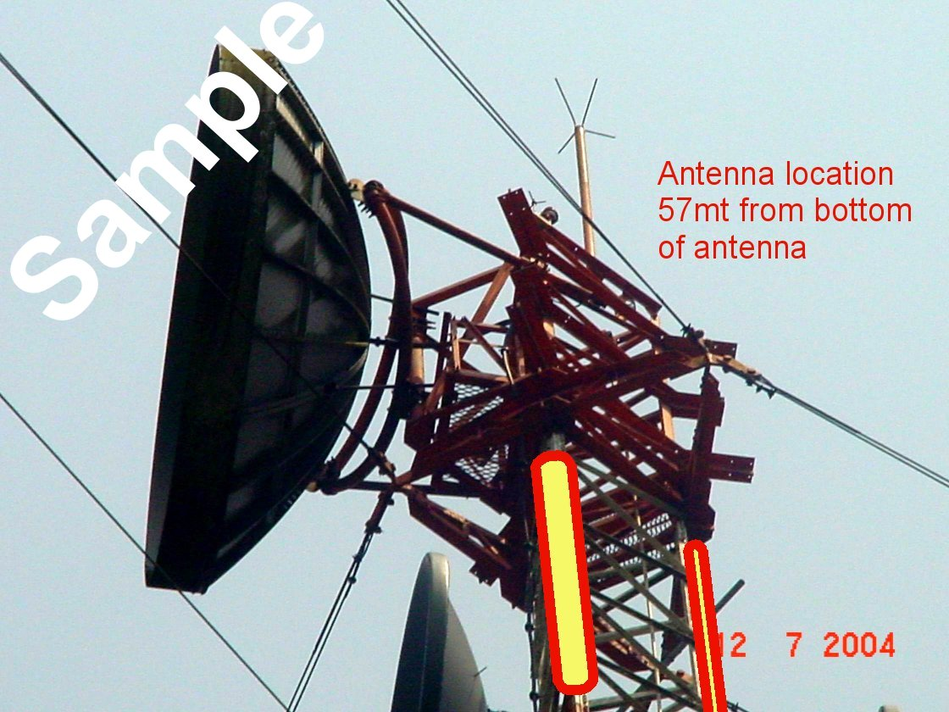
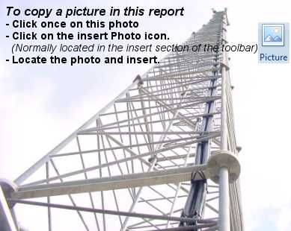
To import pictures. 1st single click on the sample pictures, 2nd go to the insert Pictures icon, 3rd browse & insert picture

Insert comments here

Insert comments here

Insert comments here

Insert comments here

Insert comments here

11) SITE PICTURES
Insert comments here
Insert comments here

Insert comments here

Insert comments here

Insert comments here

Insert comments here

